TASK 10 – Compare Expectations with Execution
10.1 Expected versus actual behaviour
The purpose of this task is to compare the predicted results with the results produced by running the program. The actual values for sizeof, floating-point totals and compiler behaviour must be measured on the computer used for submission.
For a consistent comparison, consider the maximum bill under the original 16-bit meter assumptions:
- Maximum consumption in one register cycle: 65,535 units.
- Energy charge for 101–200 units: \(100 \times ₹2.25 = ₹225.00\).
- Energy charge above 200 units: \(65,335 \times ₹4.50 = ₹294,007.50\).
- Fixed charge: ₹50.00.
- Maximum bill under these assumptions: ₹294,282.50.
This maximum is based on the specified slab rates and one meter cycle; it is not a general maximum for a smart meter that can accumulate much larger yearly totals.
10.2 District-scale calculation
Assuming every one of the 800,000 households receives the maximum bill calculated above:
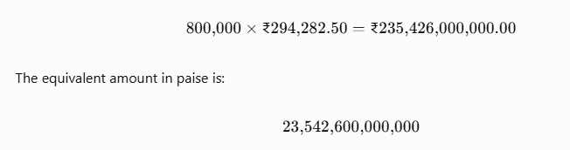
A typical 32-bit int cannot store this total. A 64-bit long long can store it comfortably on common systems. A long is 32 bits on some systems and 64 bits on others, so its capacity must be checked.
10.3 Floating-point versus integer calculation
- Integer paise gives an exact sum while the total remains within the integer type's range.
- float has limited precision, so decimal values may be approximated.
- double has more precision than float, but decimal fractions still may not be exact.
- The amount of observed difference depends on the bill values, their order, the implementation and the number of additions.
To provide the required experimental evidence, run both implementations for 4,000, 60,000 and 800,000 bills and record the differences. Do not invent a measured error without running the experiment.
10.4 Minimum guarantees and actual type sizes
C implementations can differ in the size of int, long and long long. Use sizeof, limits.h and float.h to record the sizes and ranges on the system used for submission. Compare these results with the minimum ranges guaranteed by the C standard.
10.5 Alternative concept and complexity analysis
Adding a bill to an accumulated total takes \(O(1)\) time with int, long, long long or double. Each variable occupies a fixed amount of memory on a given implementation.
Integer types can overflow when the total exceeds their representable range. Floating-point types have a large range but may lose exactness as values grow. For financial totals, a sufficiently wide integer amount in paise is preferred because exact monetary arithmetic is important.

